**CI/CD Practices in Azure Data Engineering:**

Continuous Integration and Continuous Deployment (CI/CD) practices involve automating the process of integrating code changes, testing them, and then deploying them to production environments. In Azure Data Engineering, this means automating the deployment of data pipelines, transformations, and analytics solutions.

**Example Scenario:**

Imagine you're part of a team developing a data analytics solution for a retail company. Your solution involves ingesting sales data, performing transformations, and generating reports for business insights.

**CI/CD with Azure Synapse:**

1. **Continuous Integration (CI):**

* Developers work on their features and push code changes to a central repository, such as Azure DevOps Git.
* Azure Synapse leverages CI to automatically trigger the integration process whenever new code changes are detected.
* The integration process involves building and testing the data pipelines and analytics components.

1. **Continuous Deployment (CD):**

* Once the code changes pass integration tests, Azure Synapse automates the deployment process to various environments, such as development, testing, and production.
* CD ensures that changes are deployed consistently and reliably across different environments.

**Architecture of Azure Synapse:**

Azure Synapse is a fully managed analytics service that brings together enterprise data warehousing and big data analytics. Its architecture consists of several key components:

1. **SQL Pools:**

* These are dedicated pools of compute and storage resources for running analytical queries and data transformations using SQL.

1. **Spark Pools:**

* These pools provide distributed processing capabilities for big data analytics and machine learning workloads using Apache Spark.

1. **Integration with Azure Data Lake Storage (ADLS):**

* Azure Synapse integrates seamlessly with Azure Data Lake Storage, providing a scalable and secure storage solution for big data analytics.

1. **Built-in Data Integration:**

* Azure Synapse offers built-in data integration capabilities, including data ingestion, data movement, and data transformation, allowing you to easily ingest data from various sources and perform ETL (Extract, Transform, Load) operations.

1. **Security and Governance:**

* Azure Synapse provides robust security features, including role-based access control (RBAC), data encryption, and auditing, ensuring compliance with data governance policies.

**Example Architecture:**

In our retail analytics scenario, the architecture of Azure Synapse might look like this:

* **Data Ingestion**: Sales data is ingested from various sources like transaction databases, web logs, and external APIs into Azure Synapse using built-in data ingestion capabilities.
* **Data Transformation**: Using SQL Pools and Spark Pools, data engineers transform raw sales data into meaningful insights, performing aggregations, calculations, and data enrichment.
* **Reporting and Analytics**: Business analysts and data scientists use Azure Synapse's analytical capabilities to generate reports, dashboards, and machine learning models for extracting valuable insights from the data.
* **CI/CD Automation**: Azure DevOps is integrated with Azure Synapse to automate the CI/CD process. Whenever developers push code changes, Azure Synapse triggers the integration, testing, and deployment processes automatically, ensuring that changes are deployed seamlessly across environments.

By leveraging CI/CD practices with Azure Synapse, teams can streamline the development and deployment of data engineering solutions, enabling faster time-to-insight and better decision-making for the business.

**Architecture Diagram:-**

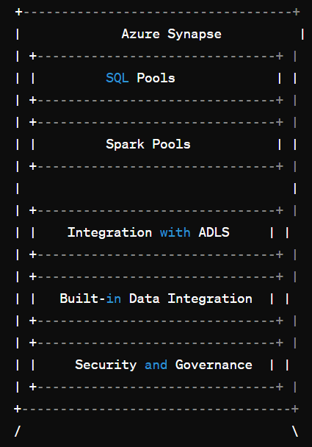

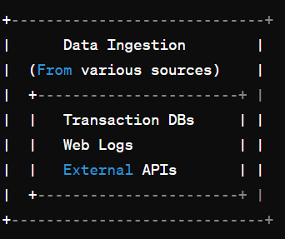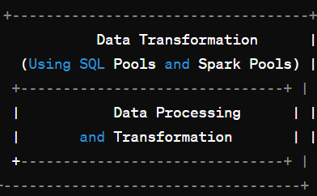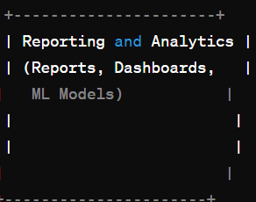

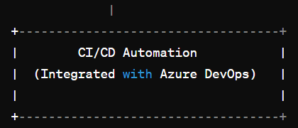

**In the diagram:-**

* **Azure Synapse**: Represents the core components of Azure Synapse, including SQL Pools, Spark Pools, integration with Azure Data Lake Storage (ADLS), built-in data integration, and security/governance features.
* **Data Ingestion**: Shows the sources of data ingested into Azure Synapse, such as transaction databases, web logs, and external APIs.
* **Data Transformation**: Illustrates the processing and transformation of data using SQL Pools and Spark Pools within Azure Synapse.
* **Reporting and Analytics**: Depicts the generation of reports, dashboards, and machine learning models based on the transformed data.
* **CI/CD Automation**: Represents the integration of Azure Synapse with Azure DevOps for automating the CI/CD process, ensuring seamless deployment of code changes across environments.

This diagram provides a visual overview of how Azure Synapse fits into the data engineering workflow, from data ingestion to reporting and analytics, with CI/CD automation ensuring efficient development and deployment processes.